«${currentDate?date?string('dd MMMM yyyy'»
MyCCA reference: «${workflow.requestId}»

Agreement identifier: «${account.targetUnitIdentifier}» CCA3 Underlying Agreement «${params.version}»
Operator name: «${account.name}»
Company number: «${(account.companyRegistrationNumber)!}»
Address for service:
By post:
«${account.location}»
Electronically:
«${account.primaryContactEmail}»

CLIMATE CHANGE AGREEMENTS SCHEME

UNDERLYING AGREEMENT ACTIVATED

Dear «${account.primaryContact}»,

We are writing to inform «${account.name}» (“you”) that we have activated your underlying agreement (“the agreement”) for the Climate Change Agreement scheme (“the scheme”), which starts on 1 January 2026 and ends on 31 March 2033.

This qualifies you to claim the Climate Change Levy discount under Part IV of Schedule 6 to the Finance Act 2000 (as amended) for each of the facilities listed within your agreement.

We will notify HMRC that we have activated your agreement and the facilities named within it.

If you haven’t already done so, you must notify HMRC and your energy supplier(s), using the PP10 and PP11 forms, to receive relief on the Climate Change Levy.

If you require any clarification of the above, please contact your sector association.

If you need to contact the Administrator for any supporting information, please use the following email: cca-help@environment-agency.gov.uk.

Yours faithfully
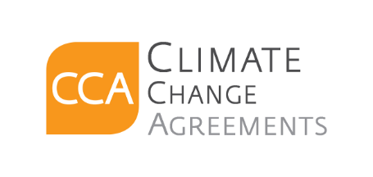
CCA Team

c.c. «[#list email.ccRecipients as cc]»«${cc}[#sep], [/#sep]»«[/#list]»

